Carnivore, Herbivore or Omnivore?
Name: Date:
Look at all of the creatures below. Guess which is a carnivore, herbivore or omnivore. As an extra challenge, who is predator and who is prey? Maybe they are both? Why? Draw a line under your answer.

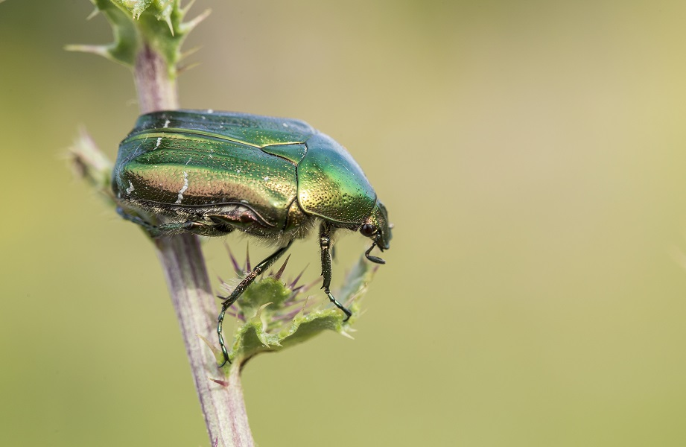
I am a rose chafer beetle.
I am a carnivore/omnivore/herbivore
I am predator/prey/both

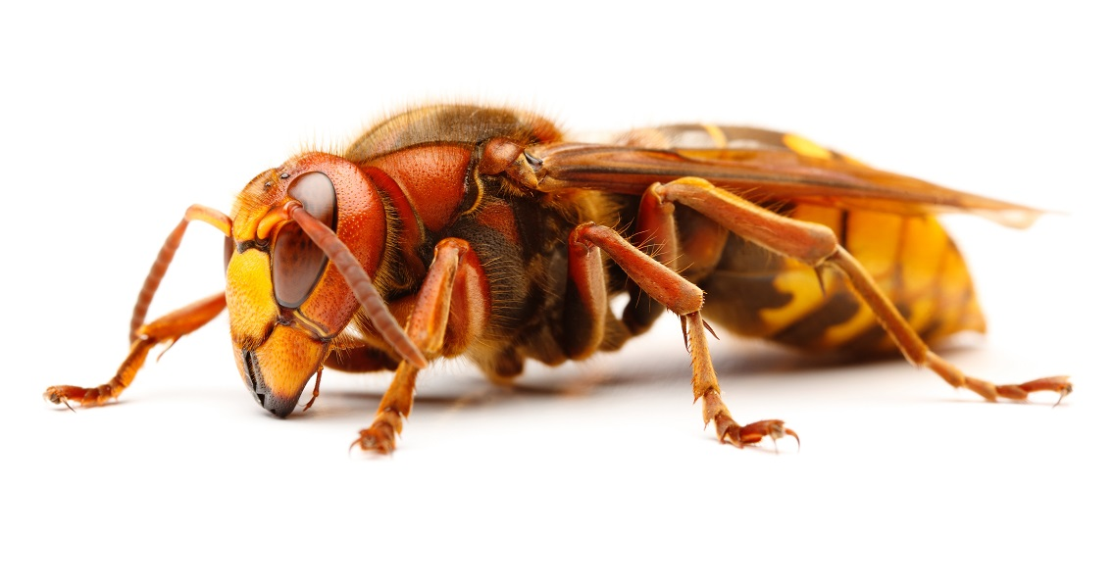
I am a European hornet
I am carnivore/omnivore/herbivore
I am predator/prey/both

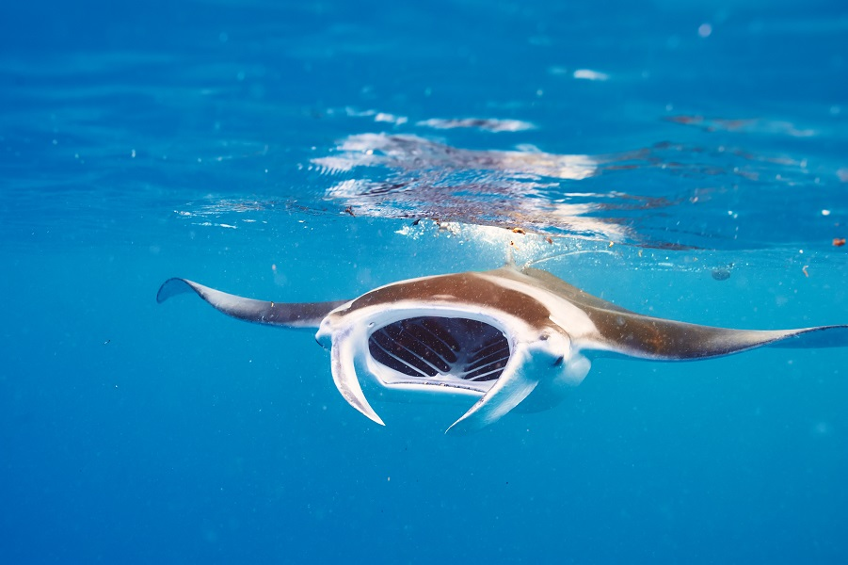
I am a manta ray.
I am a carnivore/omnivore/herbivore
I am predator/prey/both

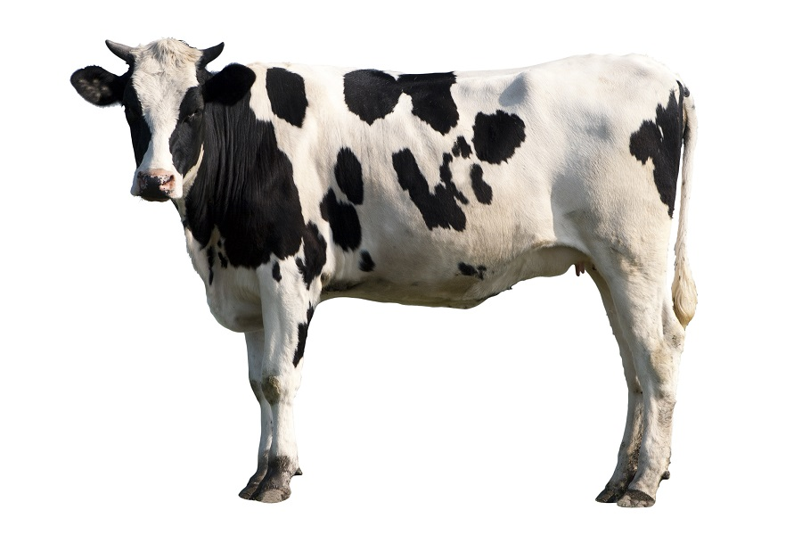
I am a cow.
I am a carnivore/omnivore/herbivore
I am predator/prey/both

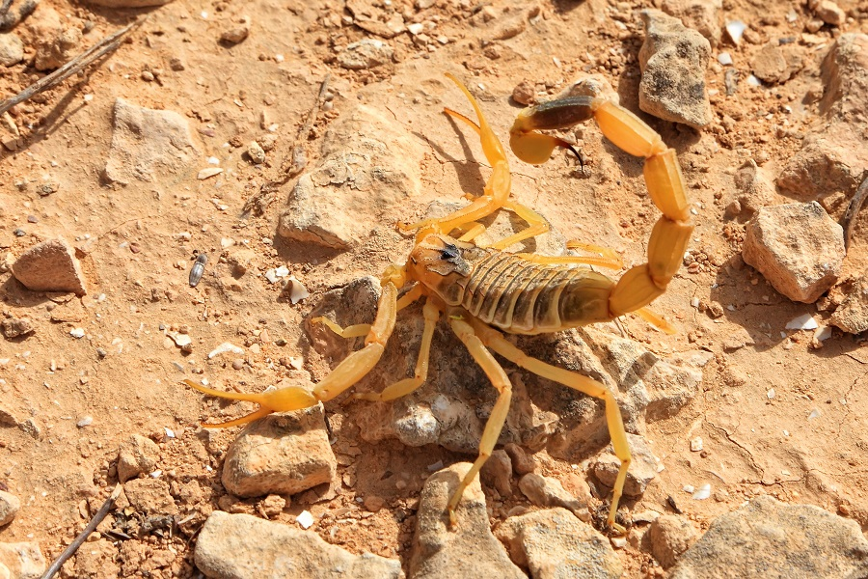
I am a death stalker scorpion.
I am a carnivore/omnivore/herbivore
I am predator/prey/both

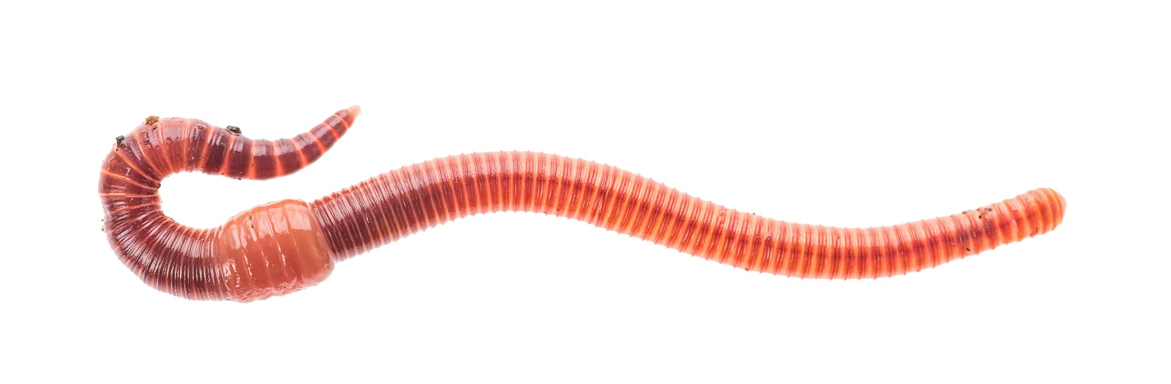

I am a worm.
I am a carnivore/omnivore/herbivore
I am predator/prey/both
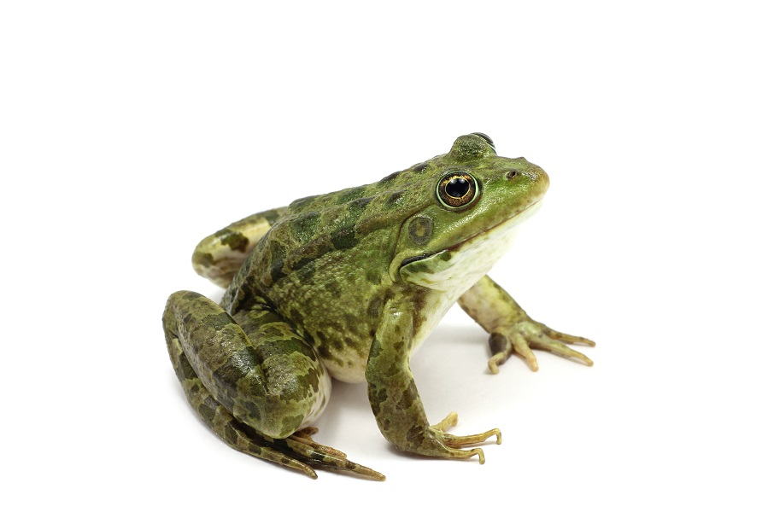
I am a frog.
I am a carnivore/omnivore/herbivore
I am predator/prey/both

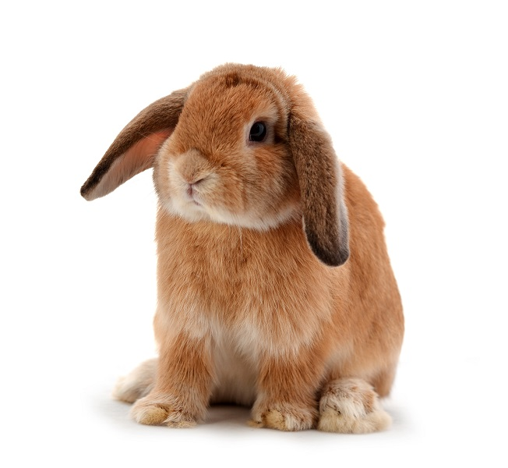
I am a rabbit.
I am a carnivore/omnivore/herbivore
I am predator/prey/both

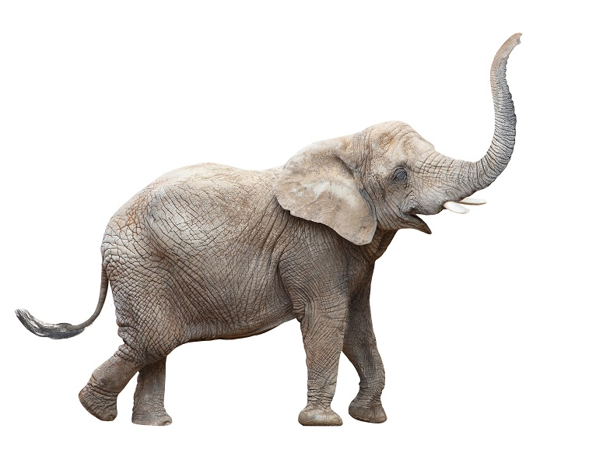
I am an elephant.
I am a carnivore/omnivore/herbivore
I am predator/prey/both

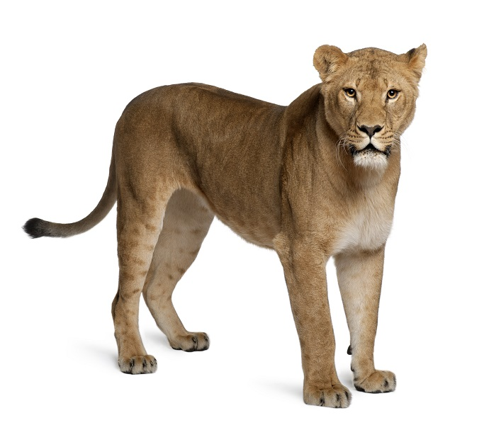
I am a lion.
I am a carnivore/omnivore/herbivore
I am predator/prey/both

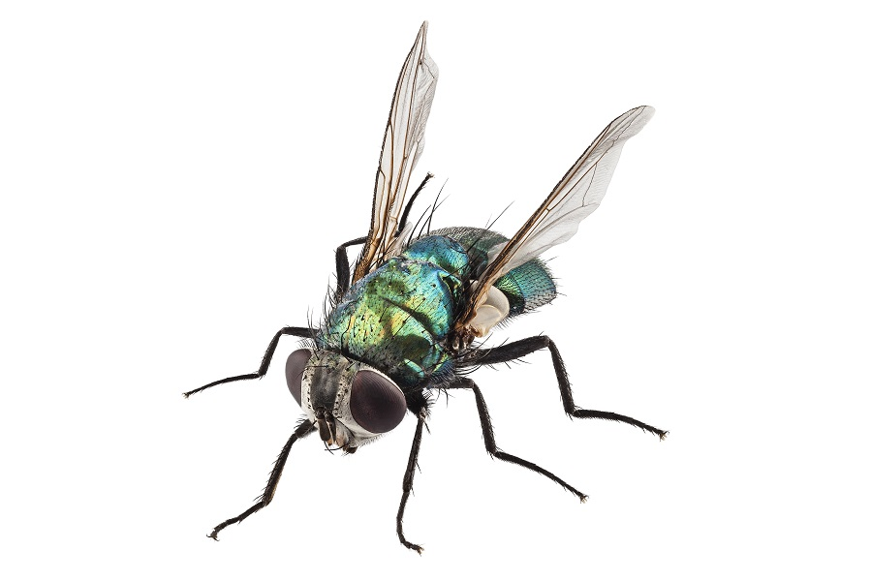

I am a fly.
I am a carnivore/omnivore/herbivore
I am predator/prey/both

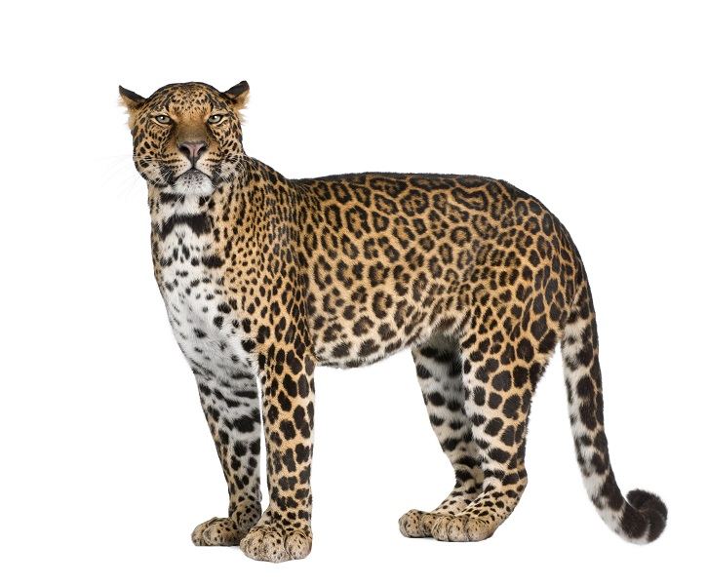
I am a leopard.
I am a carnivore/omnivore/herbivore
I am predator/prey/both

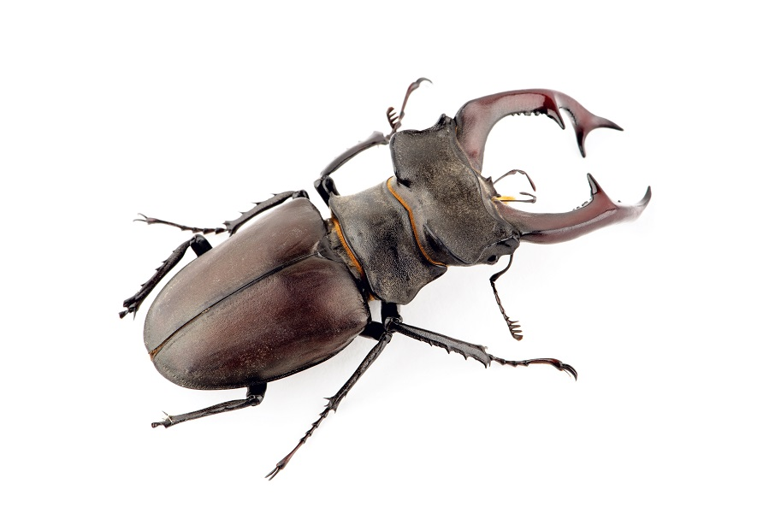
I am a stag beetle.
I am a carnivore/omnivore/herbivore
I am predator/prey/both

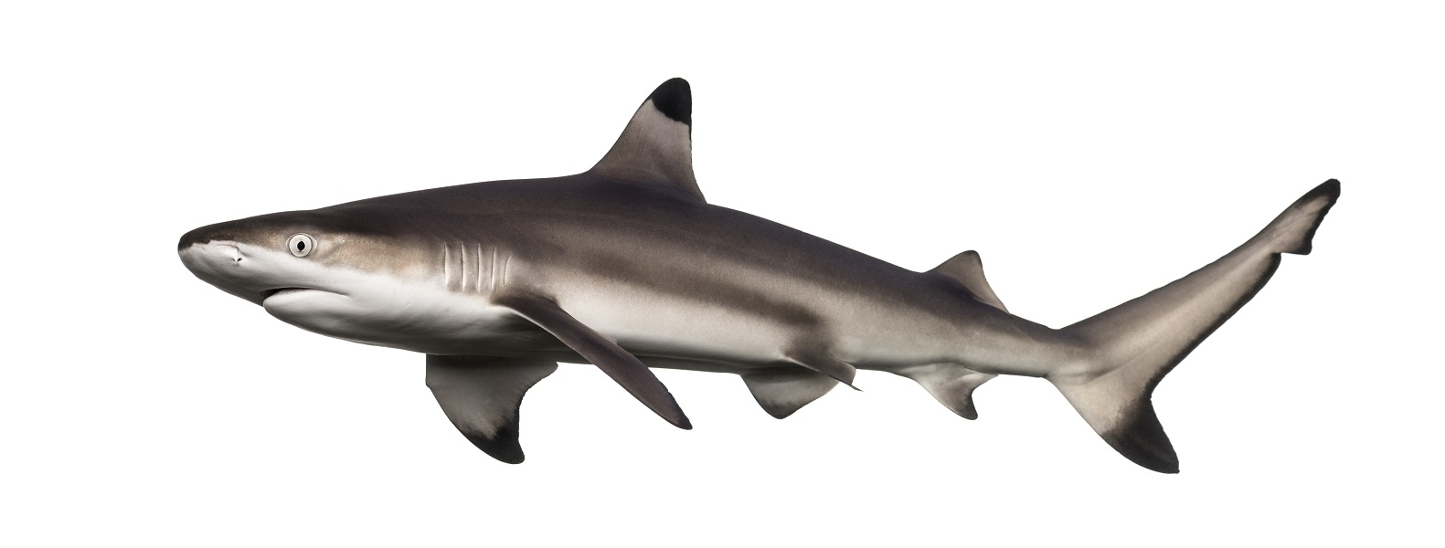
I am a shark.
I am a carnivore/omnivore/herbivore
I am predator/prey/both

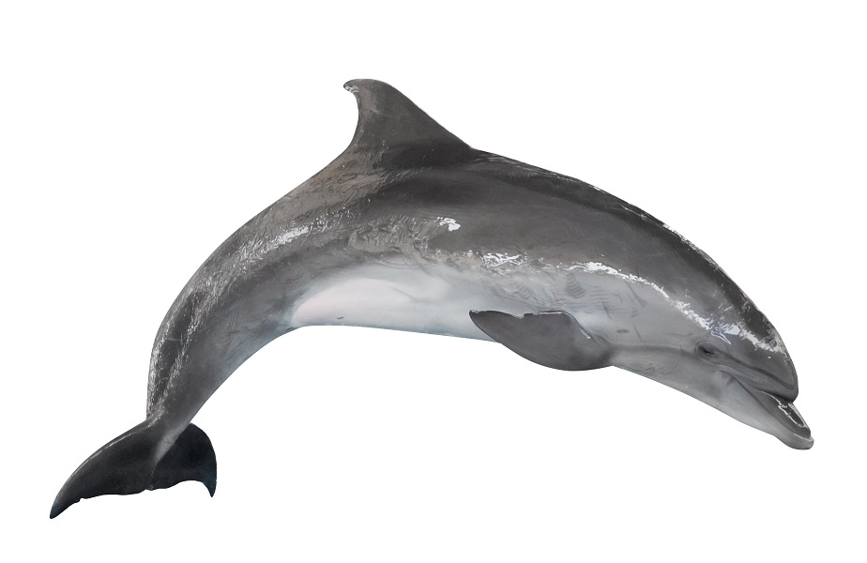
I am a dolphin.
I am a carnivore/omnivore/herbivore
I am predator/prey/both

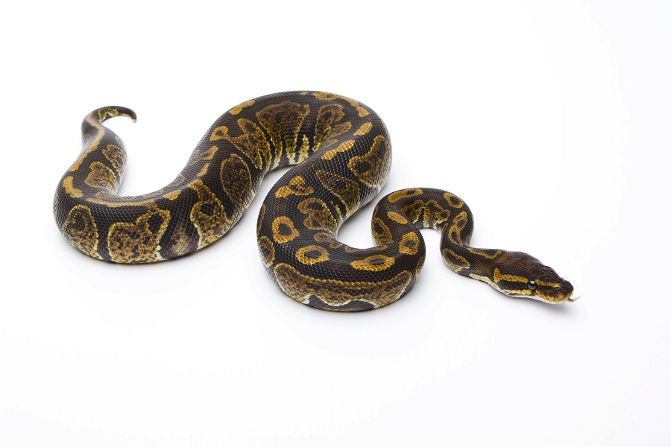
I am a snake.
I am a carnivore/omnivore/herbivore
I am predator/prey/both

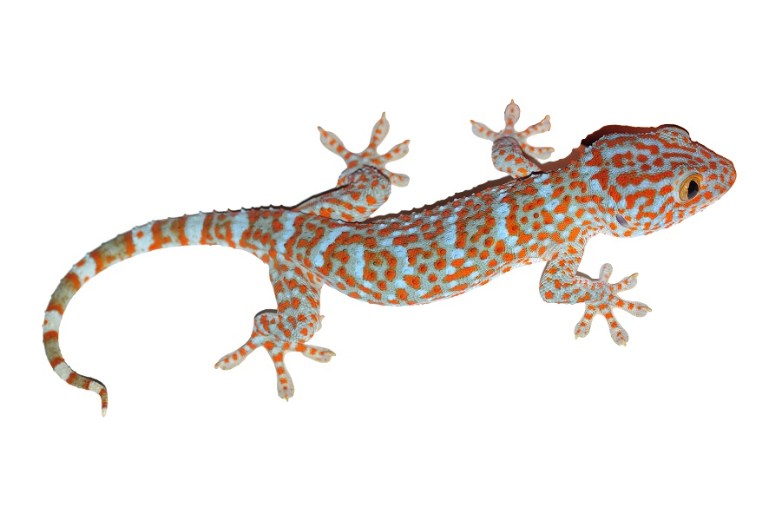
I am a gecko.
I am a carnivore/omnivore/herbivore
I am predator/prey/both

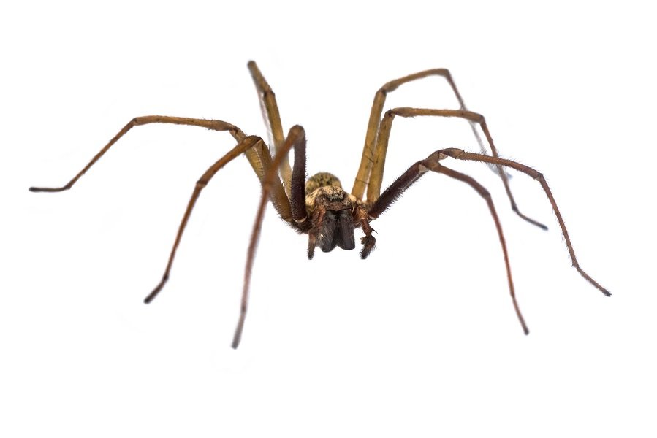
I am a spider.
I am a carnivore/omnivore/herbivore
I am predator/prey/both

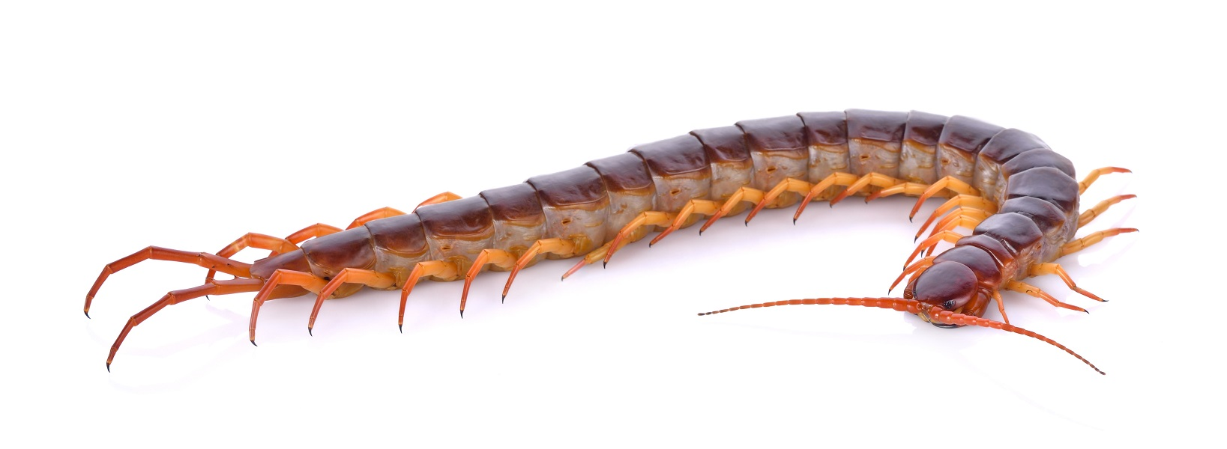

I am a centipede.
I am a carnivore/omnivore/herbivore
I am predator/prey/both
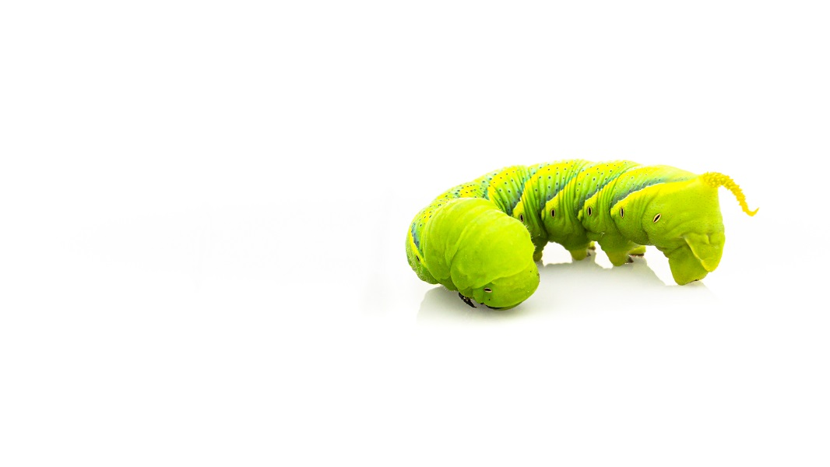

I am a caterpillar.
I am a carnivore/omnivore/herbivore
I am predator/prey/both
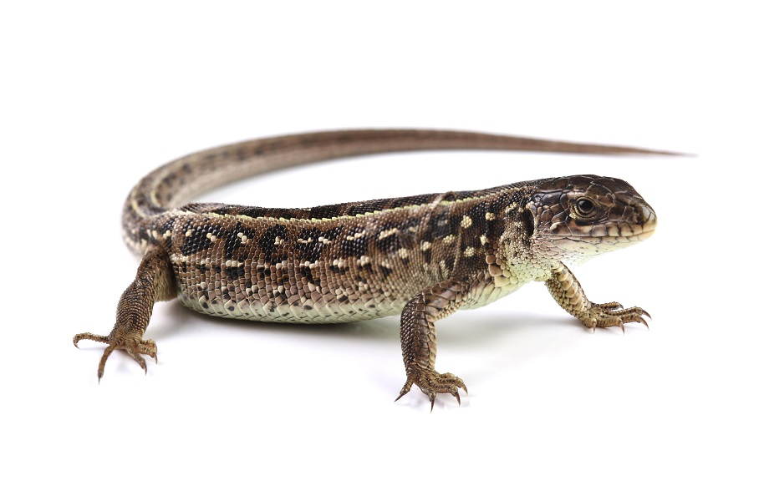

I am a lizard.
I am a carnivore/omnivore/herbivore
I am predator/prey/both

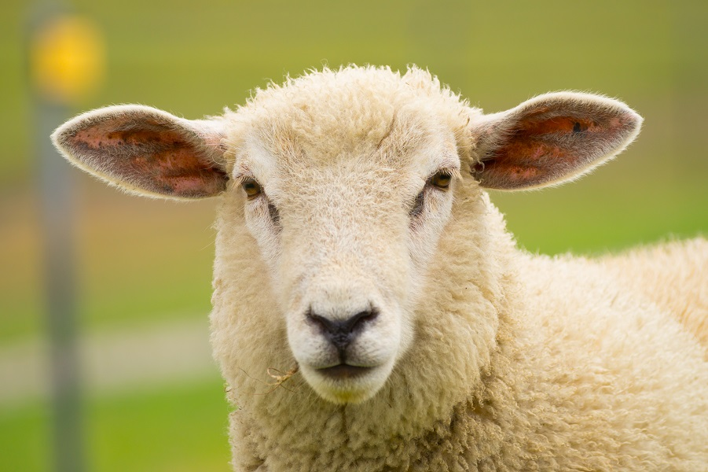
I am a sheep.
I am a carnivore/omnivore/herbivore
I am predator/prey/both

Challenge Number Two.
Choose an animal you like the best.
Draw it and label how it is adapted for its lifestyle.
Where does it live?
What does it eat?
What are its defences?

Challenge Number Three.
Design your own new species of animal.
Is it a predator?
Is it prey?
Draw it and label how it is adapted for its lifestyle.
Where does it live?
What does it eat?
What are its defences?
Does it have any super powers?

Challenge Number four.
Write a report on an animal of your choice, even the one you invented if you like.
Use formal writing.
What is its habitat?
How does it hunt or feed?
Is it endangered? If so why?
Is its habitat under threat?
What can we do about it?

